

**Final Year Project Report**

**Project Title:**

**Enhancing Airport Security Management Through Real-time Computer Vision: An AI-Powered Anomaly Detection System**

**Group Members:**

1. Muhammad Wahaj Bin Aamir (13472) (Team Leader)
2. Muhammad Arees Naseer Khan (13793)
3. Tooba Jameel (13435)
4. Taha Aslam (13794)

**Instructor Of The Project:**

Dr. Aarij Mahmood Hussaan

**Supervisor Of The Project:**

Engr. Ghalib Nadeem

**Co-Supervisor Of The Project:**

Dr. Irfan Anis

**Table Of Content**

1. **Introduction**…………………………………………………..… 3

1.1 Background………………………………………………….. 3

1.2 Problem Statement…………………………………………... 3

1.3 Project Objectives…………………………………………… 3

1.4 Scope………………………………………………………... 4

1. **Benefits**……………………………………………………..…... 5

2.1 Improved Security………………………………………...… 5

2.2 Increase Efficiency………………………………..……….... 5

2.3 Accuracy………………………………………………..…... 5

2.4 Scalability....…………………………………………….…... 5

2.5 Cost Effective…………………………………………….…. 6

1. **Requirements**…………………………………..……..………... 7

3.1 Functional Requirements………………………………...…. 7

3.2 Non-Functional Requirements…………………….………... 8

1. **Artefacts**……………………………………………………….. 9

4.1 Use Case Narrative………………………………………..... 9

4.2 Machine Learning Pipeline………………………………… 12

4.3 State Diagram……………………………………………..... 13

4.4 Prototype……………………………………………….…... 14

1. **Introduction:**

**1.1 Background:**

Airports are a function among the many infrastructural systems that enhance free flow of people and goods across the world. Nonetheless, the increased traffic in the airport has made it evidently difficult for the standards of security to be maintained. Generally, the traditional security measures that rely heavily on manual observation and human judgement are usually inadequate to detect sophisticated threats. The level of sophistication of modern threats goes above and beyond general observation and human judgement.

**1.2 Problem Statement:**

Despite robust security protocols, airports face multifaceted challenges that compromise safety and operational efficiency. Issues such as unattended baggage, unauthorized personnel in restricted areas, and irregular passenger flows are compounded by less obvious yet critical anomalies like wet floors, filled garbage bins, broken tiles, variations in light intensity, and the management of long queues. These problems highlight the limitations of traditional, labor-intensive monitoring systems, which are not only prone to human error but also often fail to address a comprehensive range of airport safety and security concerns. There is a compelling need for an automated, AI-powered computer vision system that can detect and respond to these diverse issues promptly and accurately, thereby enhancing overall airport security and operational efficiency, and supporting security personnel in upholding strict safety standards.

**1.3 Project Objective:**

The objective of this project is to design and implement an AI-based anomaly detection system capable of enhancing the security management of an airport. It will analyze real-time videos fed into the system with the use of surveillance cameras using advanced computer vision techniques and identify unusual activities or behaviors that may reflect a potential risk. This system is intended to reduce the likelihood of security breaches and strengthen human capabilities toward better safety and operational efficiency at an airport.

**1.4 Scope:**

The project is set to design and deploy a computer vision system integrated with AI algorithms to detect anomalies that take place in real time. After that, the testing and validation of the proposed system will be carried out in a simulated airport environment representing different scenarios found within an airport. The system is supposed to be developed with a high level of detection accuracy and low false positive results, along with making the system scalable and adaptive to various sizes and configurations of airports.

1. **Benefits:**

**2.1 Improved Security:**

The AI-powered anomaly detection system enhances the security of the airport by creating a system under which surveillance feeds are continuously monitored in real-time. The system is much more efficient and accurate than the human operator's eye in picking up any potential threat and ensuring timely detection and alert generation against any security incident.

**2.2** **Increased Efficiency:**

Automating the surveillance process reduces human workload on security personnel, allowing them time and focus on reacting to real threats instead of monitoring activities. It does not simply improve efficiency in security operations but also reduces the occurrence of human error; hence, it is a more reliable security system.

**2.3 Accuracy:**

One of the critical advantages of applying AI in security lies in reducing false alerts. This system is designed to provide, with high precision, the anomalies that will reduce the frequency of false positives. This ensures that only real threats set off security alerts to security personnel so that a more focused and effective response is enabled.

**2.4 Scalability:**

The system is designed to be highly scalable, making it suitable for airports of various sizes, from small regional airports to large international hubs. Additionally, the AI algorithms can be tailored to meet the specific security needs of different airports, ensuring that the system remains effective as security challenges evolve.

**2.5 Cost-Effectiveness:**

While the initial deployment of AI-powered security systems may require a significant investment, the long-term benefits include substantial cost savings. By reducing the need for extensive human surveillance and improving response times, the system can lower operational costs and prevent costly security breaches. Additionally, the enhanced security measures can improve passenger confidence, potentially leading to increased airport revenue through higher passenger volumes and satisfaction.

1. **Requirements:**

**3.1 Functional Requirements:**

1. **Real-Time Monitoring:** The system should continuously monitor the airport premises using local cameras integrated with deep learning models.
2. **Anomaly Detection System:** The system is intended to detect various anomalies in real-time to ensure enhanced operational efficiency and safety within the designated premises. Key functionalities are anticipated to include:

* Detection of unauthorized personnel in restricted areas, with immediate alert to management.
* Identification of unattended luggage or objects, enabling prompt intervention and security measures.
* Monitoring of passenger queues and immigration counters to optimize queue management, thereby minimizing waiting times and enhancing customer experience.
* Continuous monitoring of light intensity levels, with automatic alerts to management.
* Identification of areas with broken tiles, facilitating timely repair and maintenance actions.
* Detection of filled garbage bins, with alerts generated to enable timely disposal activities.
* Detection of wet floors, enabling timely mitigation to prevent slip hazards.

1. **Alert Generation:** Generate timely alerts to notify airport management when anomalies are detected.
2. **Customization:** Allow customization of detection parameters and thresholds to adapt to different airport environments and requirements.

**3.2 Non-Functional Requirements:**

1. **Accuracy:** The system should achieve high accuracy in anomaly detection to minimize false alerts and ensure reliable notifications to airport management.
2. **Reliability:** The system should operate reliably under varying environmental conditions and camera setups, with minimal downtime or disruptions.
3. **Scalability:** The system should be scalable to accommodate the growing needs of the airport, supporting additional cameras and increasing data volumes without compromising performance.
4. **Usability:** Ensure the system is user-friendly and intuitive for airport personnel, with clear interfaces and streamlined workflows for monitoring and responding to anomalies.
5. **Compatibility:** Ensure compatibility with existing Airport Management Systems (AMS) and infrastructure to facilitate seamless integration and operation.
6. **Maintainability:** Design the system with modular components and well-documented code to facilitate maintenance, updates, and future enhancements.
7. **Artefacts:**

**4.1 Use Case Narratives:**

| **Use case Name** | Unattended Baggage Detection |
| --- | --- |
| **Use case ID** | UC001 |
| **Actor** | Unattended Baggage |
| **Description** | Detects unattended baggage within the airport premises using cameras. An alert is sent to the management personnel upon detection |
| **Pre-Condition** | The camera surveillance system is operational and calibrated to detect anomalies related to unattended baggage. |
| **Post Condition** | Unattended baggage is identified, and an alert is sent to the management personnel. |
| **Basic Flow** | The camera surveillance system continuously monitors the airport premises.  When anomalies related to unattended baggage are detected, an alert containing the location and details of the unattended baggage is sent to the management personnel. |

|  |  |
| --- | --- |
| **Use case Name** | Unauthorized Person Detection |
| **Use case ID** | UC002 |
| **Actor** | Unauthorized Person |
| **Description** | Detect unauthorized persons in restricted areas within the airport premises using cameras. An alert is sent to the management personnel upon detection. |
| **Pre-Condition** | The camera surveillance system is operational and calibrated to detect anomalies related to unauthorized persons in restricted areas. |
| **Post Condition** | Unauthorized persons are identified, and an alert is sent to the management personnel. |
| **Basic Flow** | The camera surveillance system continuously monitors the airport premises.  When unauthorized persons are detected, an alert containing the location and details of the unauthorized persons is sent to the management personnel. |

|  |  |
| --- | --- |
| **Use case Name** | Wet Carpets Detection |
| **Use case ID** | UC003 |
| **Actor** | Wet Carpets |
| **Description** | Detects wet carpets within the airport premises using cameras. An alert is sent to the management personnel upon detection. |
| **Pre-Condition** | The camera surveillance system is operational and calibrated to detect anomalies related to the condition of carpets. |
| **Post Condition** | Wet carpets are identified, and an alert is sent to the management personnel. |
| **Basic Flow** | The camera surveillance system continuously monitors the airport premises.  When anomalies related to carpets are detected, an alert containing the location of the wet carpets is sent to the management personnel. |

|  |  |
| --- | --- |
| **Use case Name** | Broken Tiles Detection |
| **Use case ID** | UC004 |
| **Actor** | Broken Tiles |
| **Description** | Detects anomalies related to broken tiles within the airport premises using local cameras. An alert is sent to the management personnel upon detection. |
| **Pre-Condition** | The camera surveillance system is operational and calibrated to detect anomalies related to the condition of tiles. |
| **Post Condition** | Broken tiles are identified, and an alert is sent to the management personnel. |
| **Basic Flow** | The camera surveillance system continuously monitors the airport premises. When anomalies related to tiles are detected, an alert containing the location and details of the broken tiles is sent to the management personnel. |

|  |  |
| --- | --- |
| **Use case Name** | Variation in Light Intensity Detection |
| **Use case ID** | UC005 |
| **Actor** | Variation in Light Intensity |
| **Description** | Detect variation in light intensity within the airport premises using cameras. An alert is sent to the management personnel upon detection. |
| **Pre-Condition** | The camera surveillance system is operational and calibrated to detect anomalies related to light intensity. |
| **Post Condition** | Variation in light intensity is identified, and an alert is sent to the management personnel. |
| **Basic Flow** | The camera surveillance system continuously monitors the airport premises.  When anomalies related to variation in light intensity are detection, an alert containing the location and details of the variation in light intensity is sent to the management personnel. |

|  |  |
| --- | --- |
| **Use case Name** | Traffic in Boarding Lanes Detection |
| **Use case ID** | UC006 |
| **Actor** | Traffic in Boarding Lanes |
| **Description** | Detect traffic congestion in boarding lanes within the airport premises using cameras. An alert is sent to the management personnel upon detection. |
| **Pre-Condition** | The camera surveillance system is operational and calibrated to detect anomalies related to traffic congestion in boarding lanes. |
| **Post Condition** | Traffic congestion in boarding lanes is identified, and an alert is sent to the management personnel. |
| **Basic Flow** | The camera surveillance system continuously monitors the airport premises.  When anomalies related to traffic congestion are detected, an alert containing the location and details of the traffic congestion is sent to the management personnel. |

|  |  |
| --- | --- |
| **Use case Name** | Filled Garbage Cans Detection |
| **Use case ID** | UC007 |
| **Actor** | Filled Garbage Cans |
| **Description** | Detect filled garbage cans within the airport premises using cameras. An alert is sent to the management personnel upon detection. |
| **Pre-Condition** | The camera surveillance system is operational and calibrated to detect anomalies related to the state of garbage cans. |
| **Post Condition** | Filled garbage cans are identified, and an alert is sent to the management personnel. |
| **Basic Flow** | The camera surveillance system continuously monitors the airport premises.  When anomalies related to garbage cans are detected, an alert containing the location and details of the filled garbage cans is sent to the management personnel. |

**4.2 Machine Learning Pipeline:**

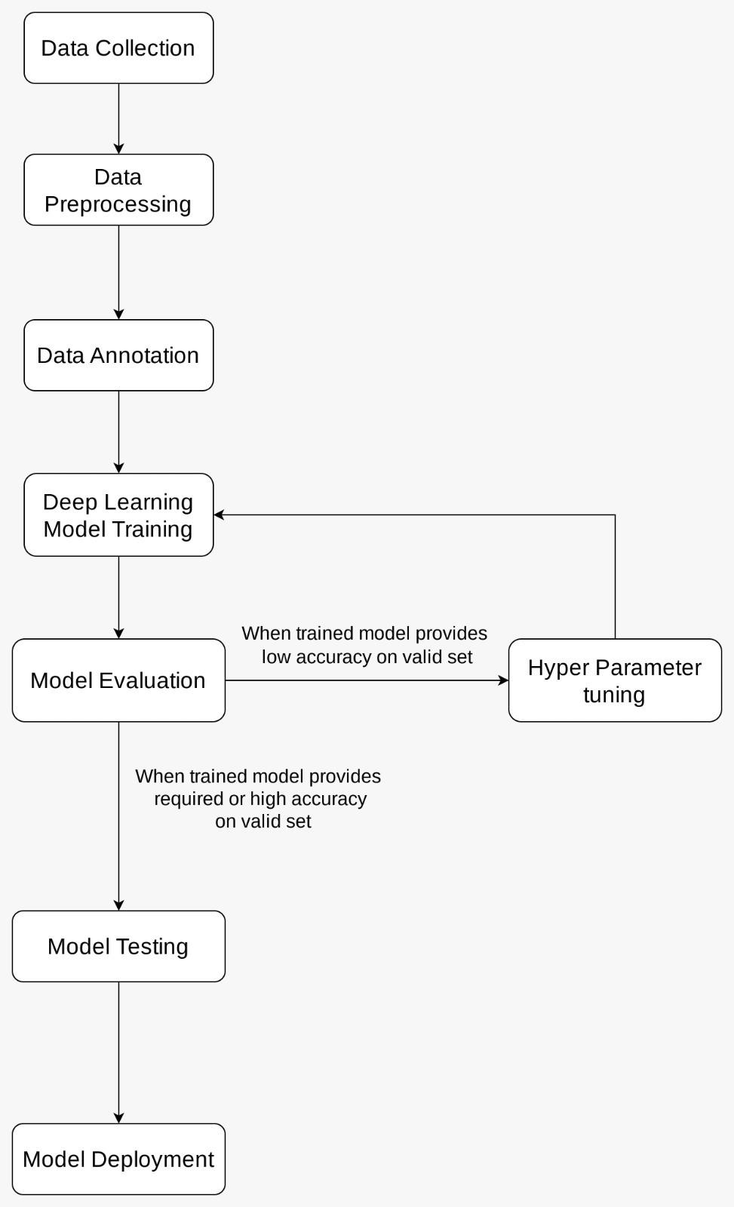

**4.3 State Transition Diagram:**

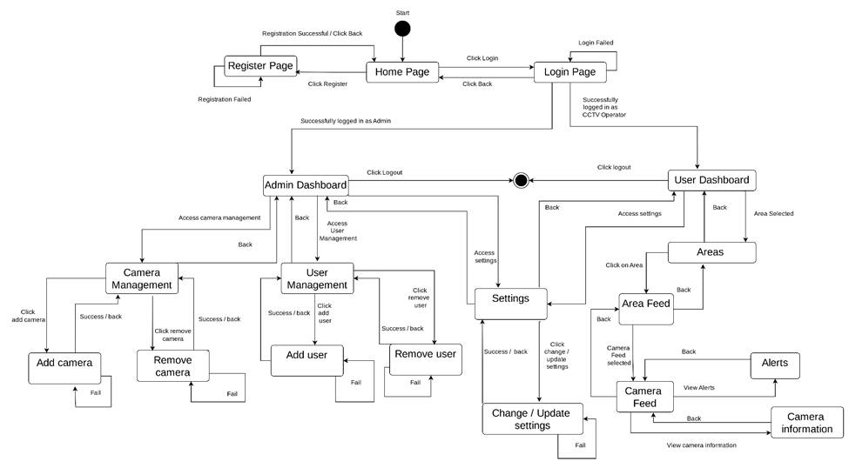

**4.4 Prototype:**

**Home Page:**



**Register Page:**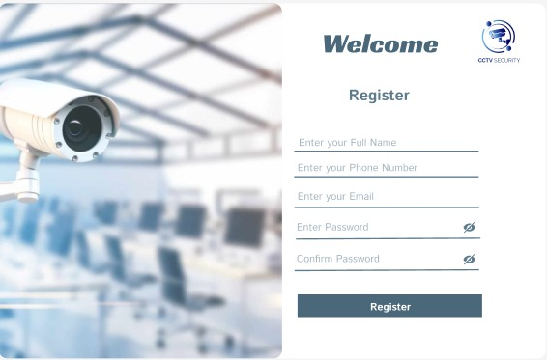

**Login Page:**

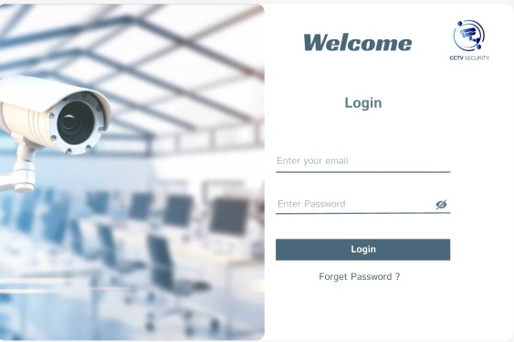

**Admin Dashboard Screens:**

**Admin Dashboard:**

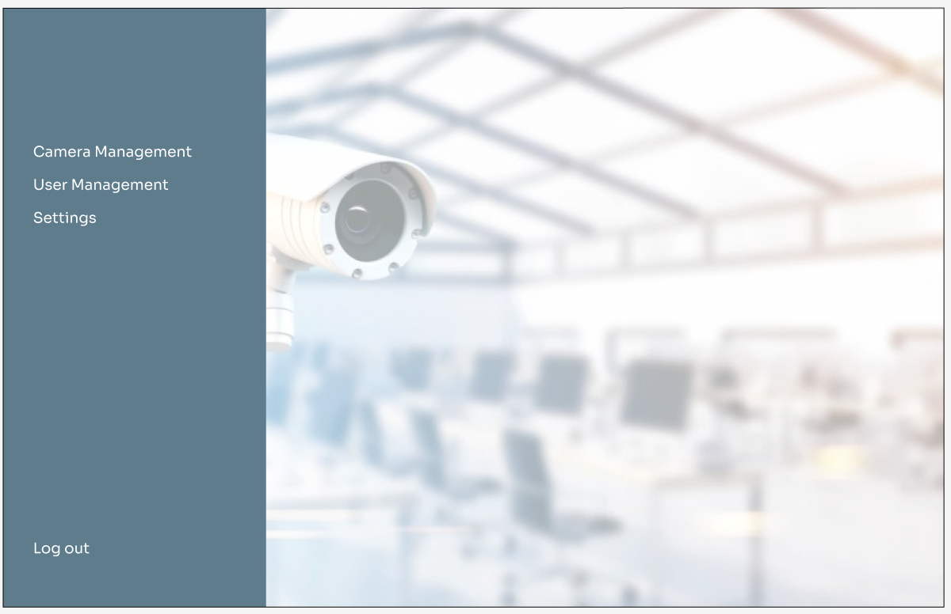

**Camera Management:**

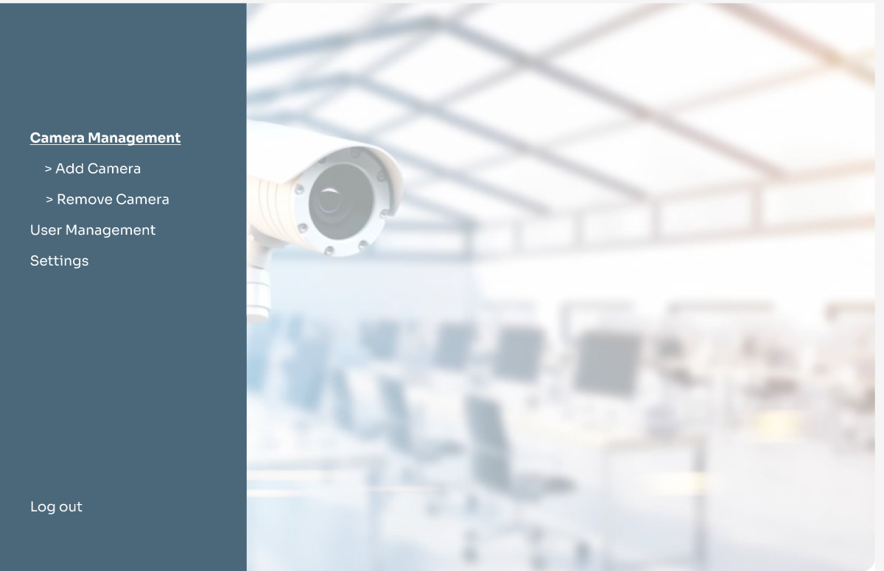

**Add Camera:**

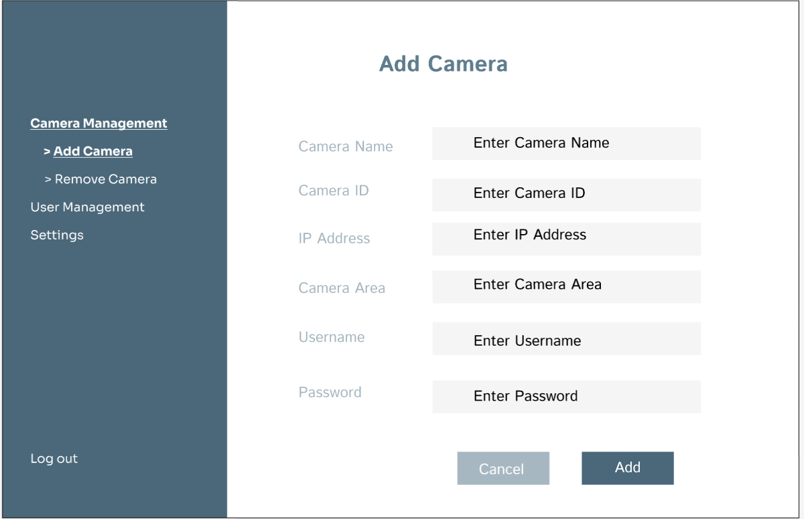

**Remove Camera:**

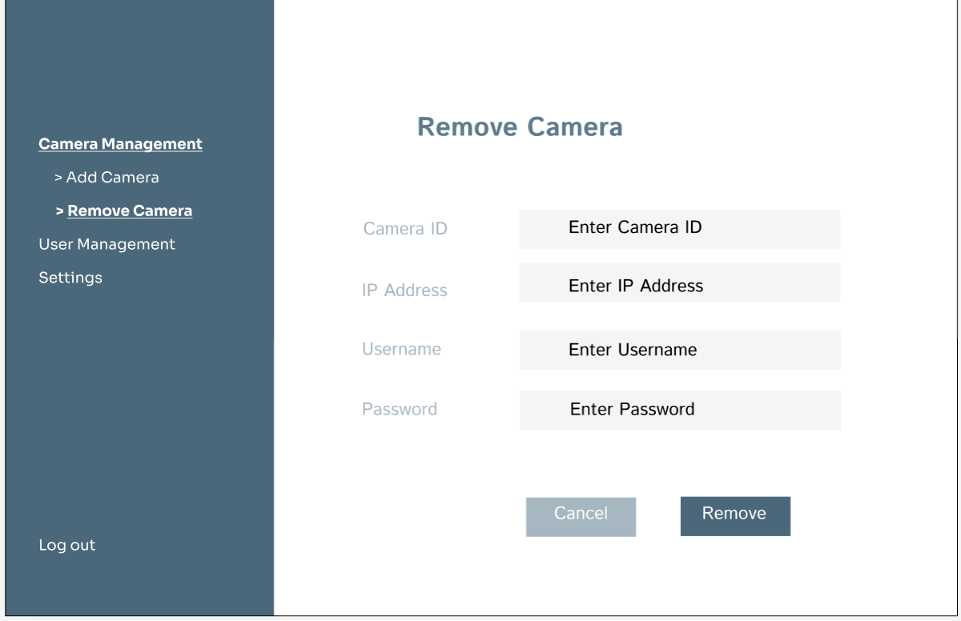

**User Management:**

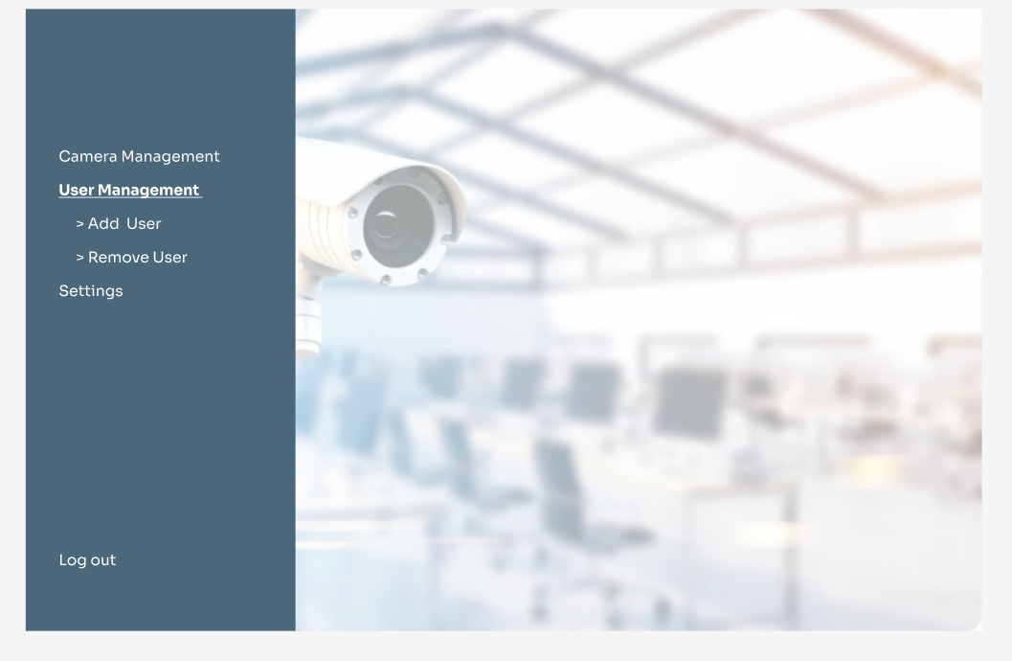

**Add User:**

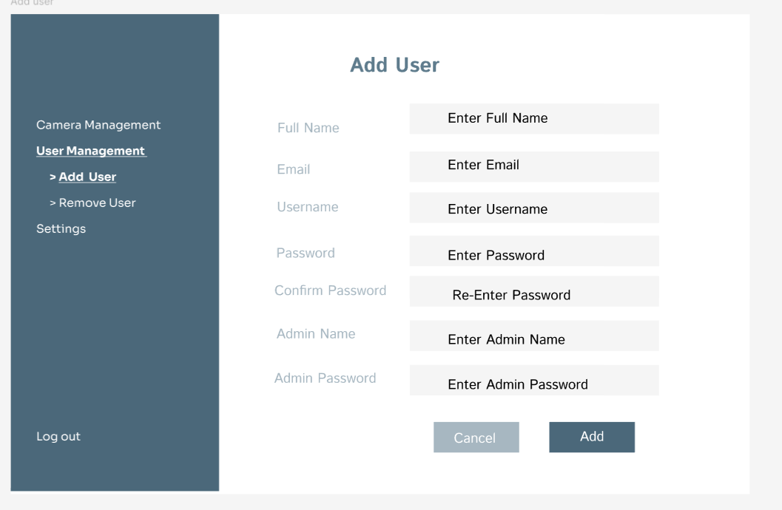

**Remove User:**

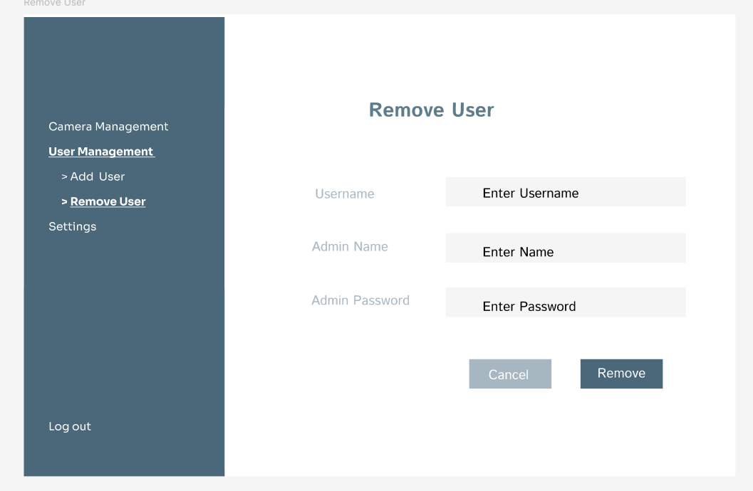

**Settings:**

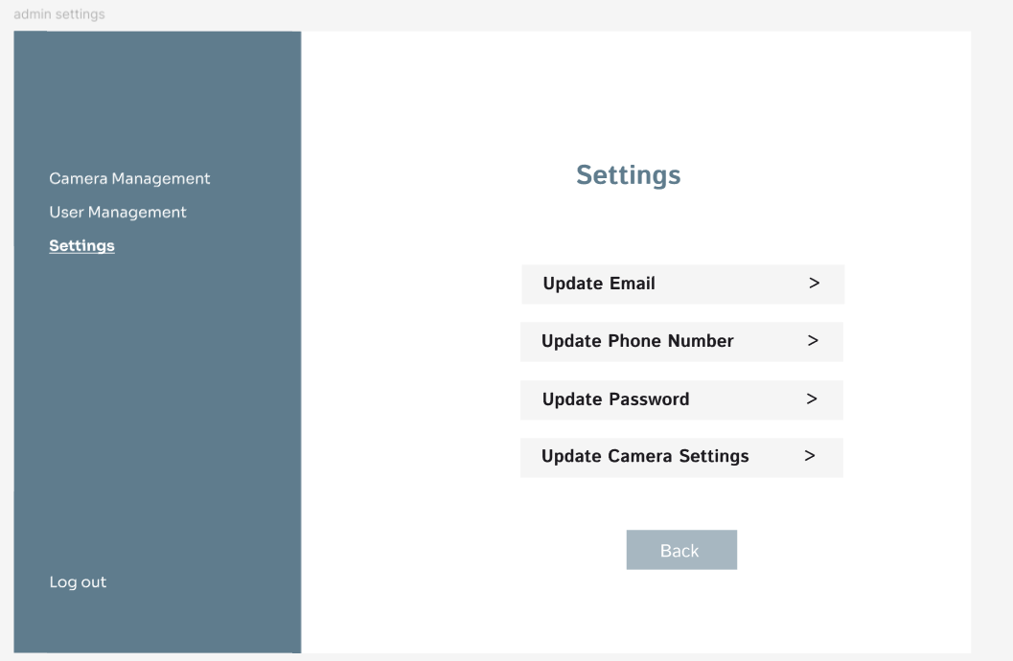

**User Dashboard Screens:**

**User Dashboard:**

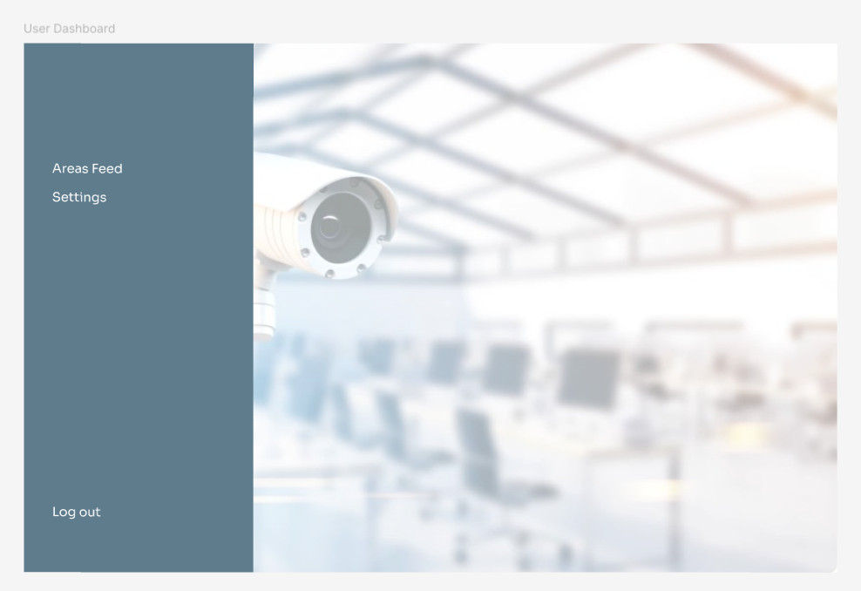

**Areas:**

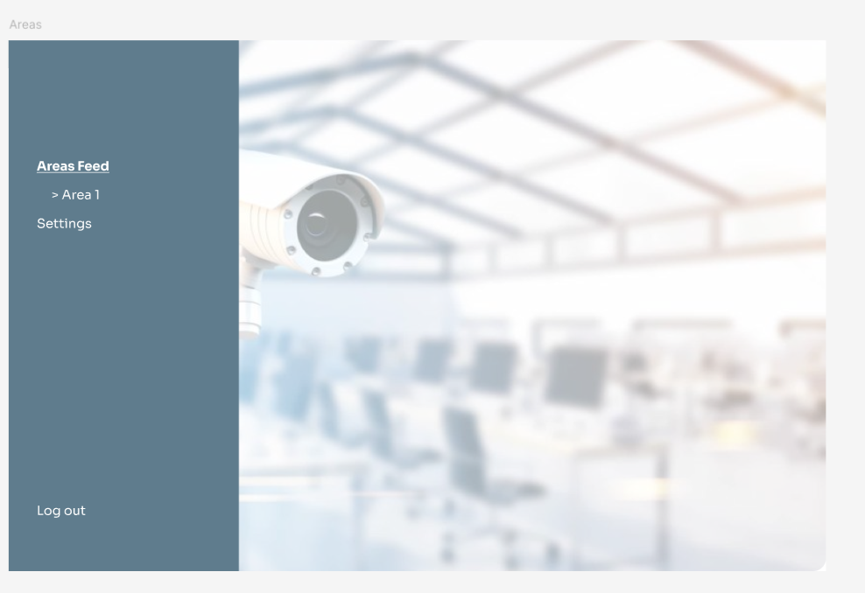

**Area Feed:**

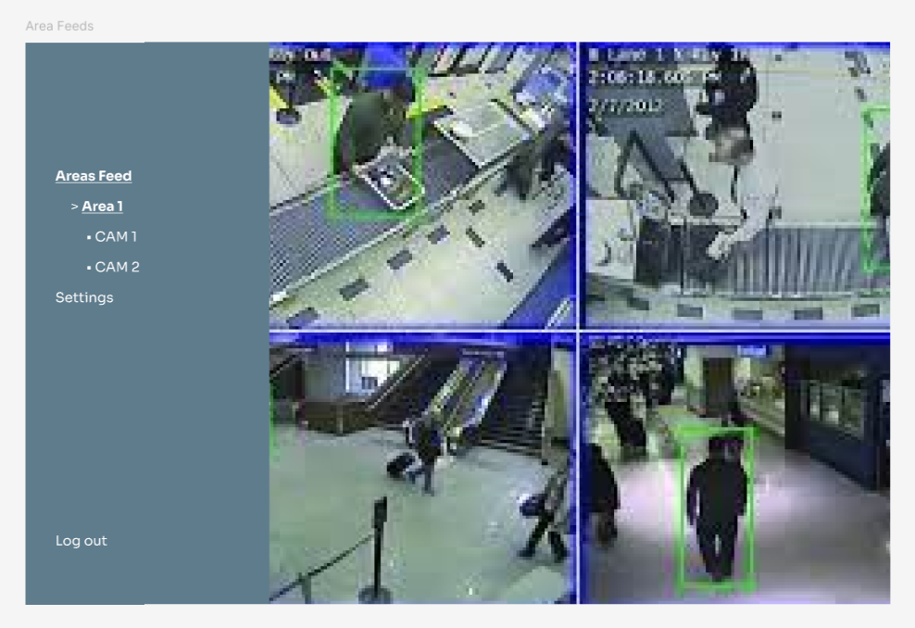

**Camera Feed:**

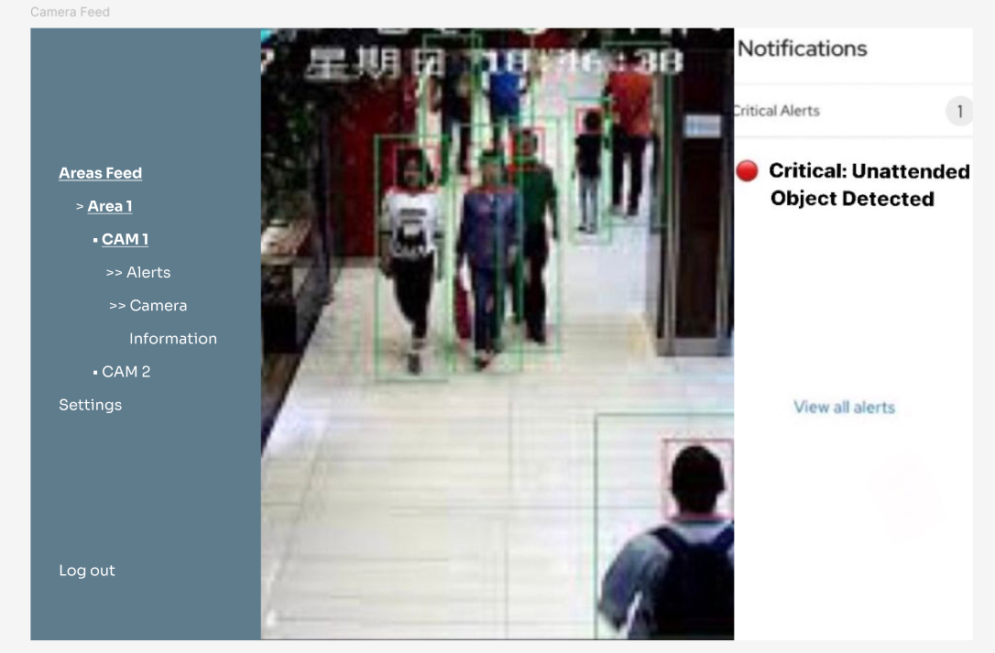

**Alerts:**

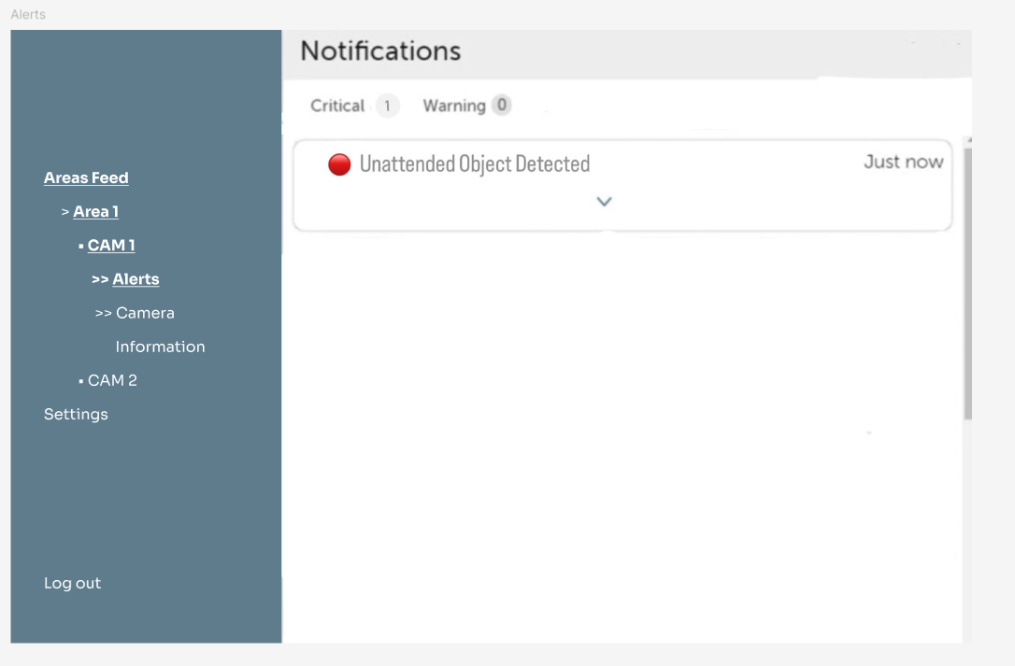

**Camera Information:**

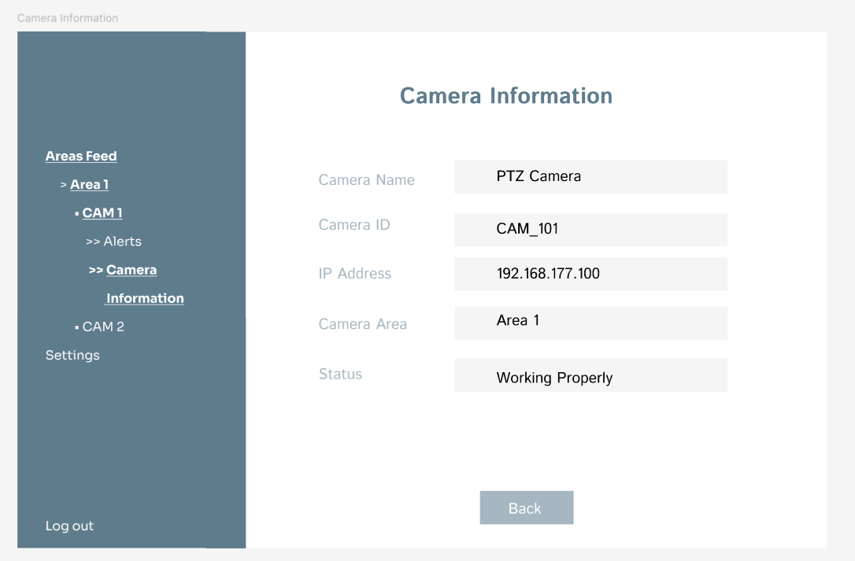

**Settings:**

